# Mongoose population

MongoDB and relations

* NoSQL databases like MongoDB normally do not explicitly support relations like the SQL databases
* All documents are normally expected to be self-contained (all info required are in the same document)
* You can store references to other documents within a document by using ObjectId’s
* Mongoose does not have joins
* Referencing documents example
  + Consider the dishes documents that are used in the exercise
    - Comments are posted by users
    - We already have a user document containing user’s information
    - Referencing the user document within the comment sub-document using objectIds
  + Modified comment schema

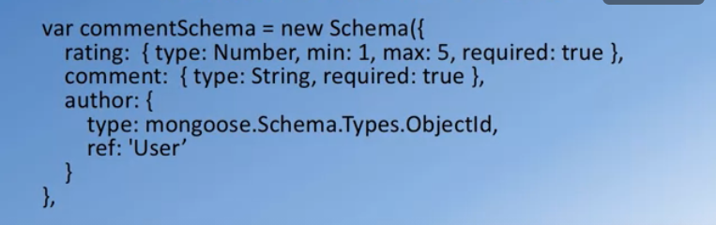

Mongoose population

* Population is the process of automatically replacing specified paths within a document with documents from another collection
* Populating documents

